10-December
2015
SHIP HOTEL ONLINE BOOKING SYSTEM
08
Fall

HIGHER COLLEGES OF TECHNOLOGY

s950001348

Table of Contents
Analysis of the system requirements for a business problem: 2
1.2. Description of System Development Life Cycles used in project 3
1.3. Description of Fact-Finding Techniques used in requirement gathering process 4
1.4. List of User Requirements 5
2. Functional and Behavioral Model of the business system: 6
2.1. Create use case diagram of the system 7
2.2. Write use case description for use cases 7
2.3. Create activity diagram of the system 8
Activity diagram for Login 8
Activity diagram for Room Booking 9
2.4. Create behavioral model of the system 10
Sequence diagram for login 10
Sequence diagram for booking room 10
3. Design of the business system: 11
3.1. Design user interface screens for all components of the system 11
3.2. Design relational database model for all components of the project 13
4. Structural Model of the business system: 14
4.1. Create Class diagram of the system for all components of the system. 15
4.2. Create Object diagram/structural model of the system covering all components of the system. 16
5. Reference Page 16

Analysis of the system requirements for a business problem:
The project on ship hotel online booking system describes the background and history of the business organization, its target audiences, and its location and market. The problem faced by the organization while developing the ship hotel online booking system project have also been described under this section and the solutions to those problems have also been proposed. The software development life cycle phases like planning, requirement analysis, design, implementation, test, and maintenance have also been described.
  - Introduction of the Problem Definition

    - Description of the system background

The SANDA business organization provides the booking of rooms in ship hotel as per its customers’ requirements. The objective of this business organization is to provide a reliable system so that customers can easily get registered at any point of time. Moreover, this organization aims at providing best quality of services to its clients. The key clients of this business organization are the corporate level clients who originate from domestic and international markets.

    - Description of the problem statement

- The existing system provides manual booking of rooms which consumes more time of clients as well as executives. Moreover, the process of checking the list of available rooms is too difficult for the executives as it requires manual work which also consumes more time.
- The executives find it difficult to search room and collect payments from the clients with the existing system.
- Sometimes, the errors may also arise while doing manual writing which makes the existing system inconsistent.
- Due to manual writing the inaccuracy arises in some records which makes the records inconsistent.

    - Description of proposed solution

This project aims at producing such a system which provides online booking of ship hotel rooms. The aim of this project is to provide a reliable system to the executives and customers so that they can use the system in an effective and efficient manner without wasting much time.
Scope:
- The proposed solution removes the manual working done by executives while registering the clients.
- The proposed system helps the business organization in maintaining online information by making the whole system computerized.
- Any user can easily interact with the new system.
Objectives:
- The objective of the new proposed solution system is to provide an automated hotel online system.
- The new system helps the executives in performing several functions like searching for the available rooms and managing the new records.
- This system enables its clients to give their feedback which helps the business organization in improving their system as per their clients’ requirements.
- This system allows its clients to book rooms from the comfort of their homes without wasting their much time.

  - Description of System Development Life Cycles used in project
In order to fulfill the business organization’s needs as well as customers’ needs, the Software Development Life Cycle (SDLC) plays an important role in capturing changing system requirements by obtaining feedback from system users. The Systems Development Life Cycle (SDLC) model is the one which helps in developing an appropriate system for the SANDA business organization. The basic steps followed by the SDLC while developing the ship hotel online booking system include planning, requirement gathering and analysis, design, implementation, and maintenance. For building the IT infrastructure for a ship hotel online booking system, the planning phase is a critical phase as it provides the basis for the entire system. The requirement gathering and analysis phase collects and then analyzes the requirements necessary to develop the system. The design phase prepares the design of the proposed system. In the implementation phase, the final system is implemented and in the final phase (maintenance phase), the implemented system is maintained to meet changing needs of customers.

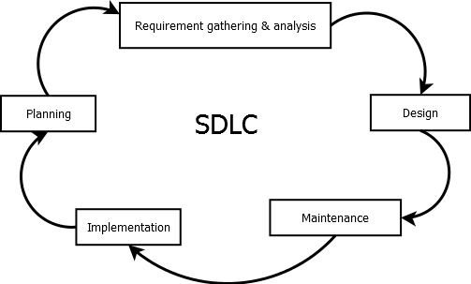

  - Description of Fact-Finding Techniques used in requirement gathering process
In order to develop the new system, the main objective of system analysis is to gather as much as information as available. For the system development, this collected information is bases of the project. The information about the system to be developed is needed to be gathered. Moreover, the information related to how to use the system is also needed. Thus, in gathering requirements, the fact finding techniques play an important role as these techniques gather latest information regarding the system to be developed. Such fact-finding techniques include interviews, questionnaires, and direct observation.

Under the questionnaires fact-finding technique, it is necessary for the market researcher to ask right questions so as to get required results. This technique is used to perform questionnaires on several respondents. This technique involves the quick response from the multiple respondents. The questions to be asked can be open ended, closed, and mixed. The poor questionnaires lead to poor results. In order to perform questionnaires, the questions can be asked from customers and these questions may include:
- How you want the new system to be?
- What problems you faced in previous system?
- Do you think to implement an online system is a good option?
- What can be the advantages and disadvantages of this system?

  - List of User Requirements
    - List of functional requirements
The fundamental actions that the system must perform are listed under the functional requirements. And, the several different functional requirements that must be fulfilled are:
- The system to be proposed must maintain the records of all bookings.
- The system must manage the customer record which includes the customer id, customer first name, customer last name customer address, customer phone number, and number of occupants.
- The prices of the different rooms must be listed by the system.
- The system must record, the check-in time as well as check-out time.
- The system must keep track of all meals purchased by the customers.
- Finally, the system must checkout the customers
    - List of non-functional requirements
The non-functional requirements describe the needs of the system to be proposed in terms of system performance, reliability, availability, etc. Several different non-functional requirement of the system are:
- The system must verify the login details within few seconds so as to perform in a better way.
- The results of the queries asked by the customers must be returned immediately.
- The system must meet all the required design constraints.
- The system must show the consistent data.
- During the hotel operating hours, the system should be available.
- The system must provide the security of the information.
- The system should be compatible under all environment conditions.

    - List of Usability requirements
The usability requirements deal with the qualitative as well as quantitative measurements of the system. These requirements include several different factors which are as follows:
- Efficiency: This factor deals with the efficiency of the system to be design. The system must be efficient to be used.
- Error-free: The system must not result into the errors while performing any operation.
- Satisfaction: The system must satisfy all the users’ requirements.
- Learnability: It should be easy for the executives as well as customers to use the system.
- Functional and Behavioral Model of the business system:
This section delivers the use case diagram of the ship hotel online booking system, its description, activity diagram and the behavioral model of the ship hotel online booking system. The use case diagram describes how the different actors interact with all the use cases involved in the system. The activity diagram describes the sequence of activities being performed to develop the system.

  - Create use case diagram of the system
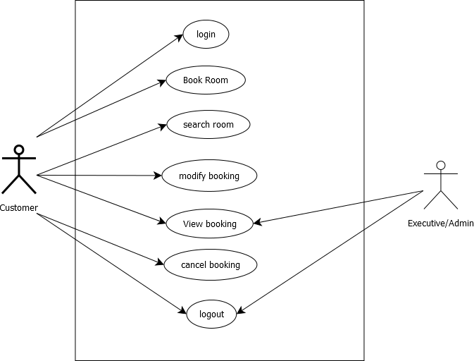

  - Write use case description for use cases
The Use Case Diagram for ship hotel online booking system constitutes several actors and use cases. The actors included in the above use case diagram are:
- Customer, and
- Executive/Admin.
The Use Cases involved in the use case diagram are:
- Login,
- Book room,
- Search room,
- Modify booking,
- View Booking,
- Cancel Booking, and
- Logout.
The actors interact with different use cases through a link known as association. The several main use cases involved in the Use Case Diagram of ship hotel online booking system are:
Login
The customer logs into the system in order to book the rooms. If the customers are not registered, then they will first register themselves and then logs into the system through the user id and password.
Book Room
After successfully logs into the system, the customers can easily book the required number of rooms by entering their personal details like customer name, customer address, customer mobile number, number of occupants, etc.
Search Room
The customers can check for the availability of rooms in order to check whether the rooms are available or not.

  - Create activity diagram of the system

Activity diagram for Login

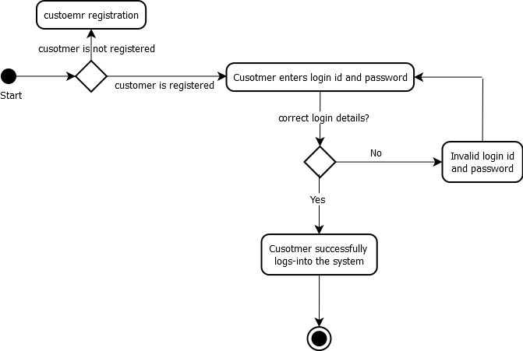

Activity diagram for Room Booking

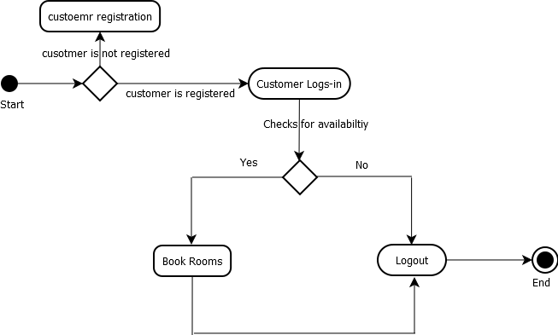

  - Create behavioral model of the system

Sequence diagram for login
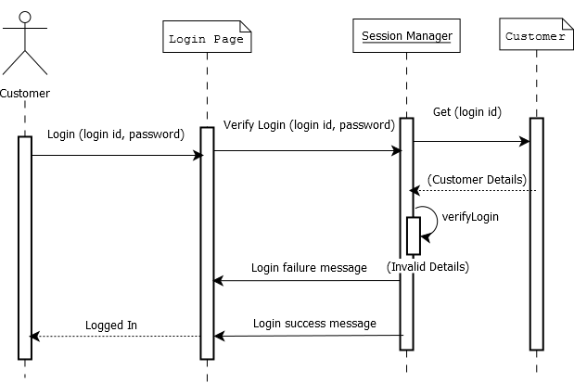

Sequence diagram for booking room
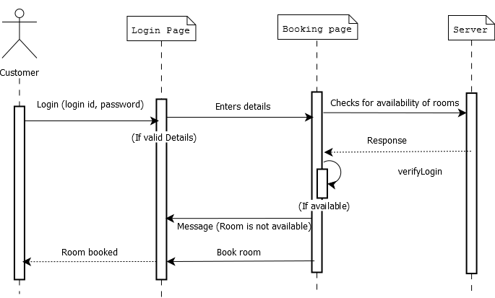

- Design of the business system:
The third section is the “Design of the business system”. The detailed requirements for the section 3 are listed in the attached template. The section 3 will contain the following items:

  - Design user interface screens for all components of the system
Login Page
Ship Hotel Online Booking System

Login ID

Password

Login
Cancel

Room Booking Page

Ship Hotel Online Booking System

Customer Name

Address

Mobile Number

Number of Occupants

Number of Room

Book
Cancel

Screen Control | Use case ID | UI screen Number | Reason to use specific screen control
Label | 1 | - | The names of the customer details like names, mobile number, etc need not to be changed; therefore, they are represented through label screen control.
Text Area | 2 | - | Text area has been used for address field so as to represent the address in multiple lines.
Text Field | 3 | - | Text field is used for normal entries which can be changes at any time.
Dropdown List | 4 | - | Dropdown list has been used to show multiple options from which user can select required one.
Button | 5 | - | To perform an action like to book the room or to cancel the room, button is required.

  - Design relational database model for all components of the project
- Registration
Sr.No. | Field Name | Data Type
1. | Customer id | Integer
2. | password | Varchar(50)
3. | Customer name | Varchar(50)
4. | Customer address | Varchar(200)
5. | Customer phone number | Integer

- Login
Sr.No. | Field Name | Data Type
1. | Username | Varchar(50)
2. | Password | Varchar(50)
2. Book
Sr.No. | Field Name | Data Type
1. | Customer Name | Varchar(50)
2. | Address | Varchar(200)
3. | Mobile Number | Integer
4. | Number of Occupants | Integer
5. | Number of required rooms | Integer

- Structural Model of the business system:
The structural model of the business system includes the class diagram of the ship hotel online booking as well as the object diagram of the system.

  - Create Class diagram of the system for all components of the system.
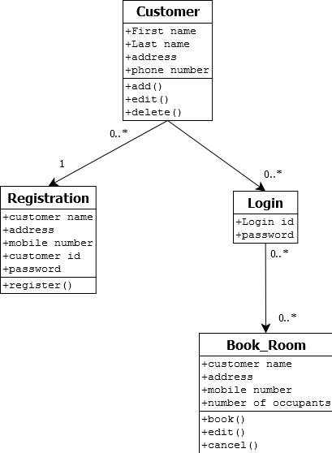

  - Create Object diagram/structural model of the system covering all components of the system.
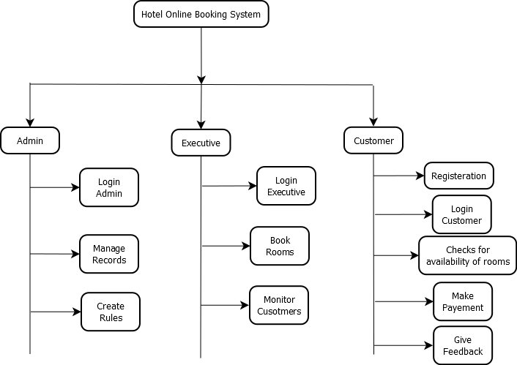

- Reference Page
- Bainbridge, A. (2003, February). SHIP HOTEL BOOKING PROCESS . Retrieved November 27, 2015, from http://www.tourcms.com: http://www.tourcms.com/company/research/pdf/ship hotel_booking_process_february2003.pdf
- Ship hotel Marketing Plan. (n.d.). Retrieved November 27, 2015, from http://www.mplans.com: http://www.mplans.com/ship hotel_marketing_plan/situation_analysis_fc.php
- SYSTEM ANALYSIS. (n.d.). Retrieved November 27, 2015, from https://www.google.co.in: https://www.google.co.in/url?sa=t&rct=j&q=&esrc=s&source=web&cd=6&cad=rja&uact=8&ved=0ahUKEwiewLy-gLDJAhWBcY4KHa6hDp0QFgg7MAU&url=http%3A%2F%2Fwww.mediu.edu.my%2Fwp-content%2Fuploads%2Flesson-3-requirement-gathering.docx&usg=AFQjCNEDxz6LGZlQA7SdTBn3Ky64Nv
- Ten Steps Towards Designing a Questionnaire. (n.d.). Retrieved November 27, 2015, from http://www.wireuk.org: http://www.wireuk.org/ten-steps-towards-designing-a-questionnaire.html
- vidya_shankar. (2013, January 12). Ship hotel managementsystemcorrectfinalsrs. Retrieved November 27, 2015, from http://www.slideshare.net: http://www.slideshare.net/vidya_shankar/ship hotel-managementsystemcorrectfinalsrs

